EX NO:08
DATE:
MOVIE RATINGS AND BUDGETS ANALYSIS

AIM: To analyze movie budgets, audience ratings, and critic ratings using the Movie-Ratings.csv dataset for the years 2007 to 2011 in Tableau. To create visualizations comparing movie genres, release counts, ratings, and budgets, and to combine all charts into an interactive dashboard.
Problem Statement: Domain: Entertainment Industry:
You have been approached as an analytics consultant by a movie reviews company. They are writing up an articles analyzing movie ratings by critics and audience as well as movie budgets for the years 2007 till 2011. You have been asked to perform the tasks: Refer the dataset: Movie-Ratings .csv

Task 1: Create a chart displaying Budget of Movies across different Genres over a period of time.
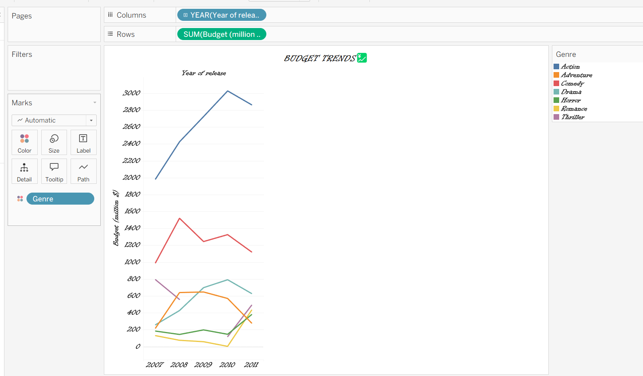
INTERPRETATION: Compares movie budgets across different genres from 2007 to 2011 and helps identify changes in budget over time.

Task 2: Create a chart showing the correlation between audience and critic ratings
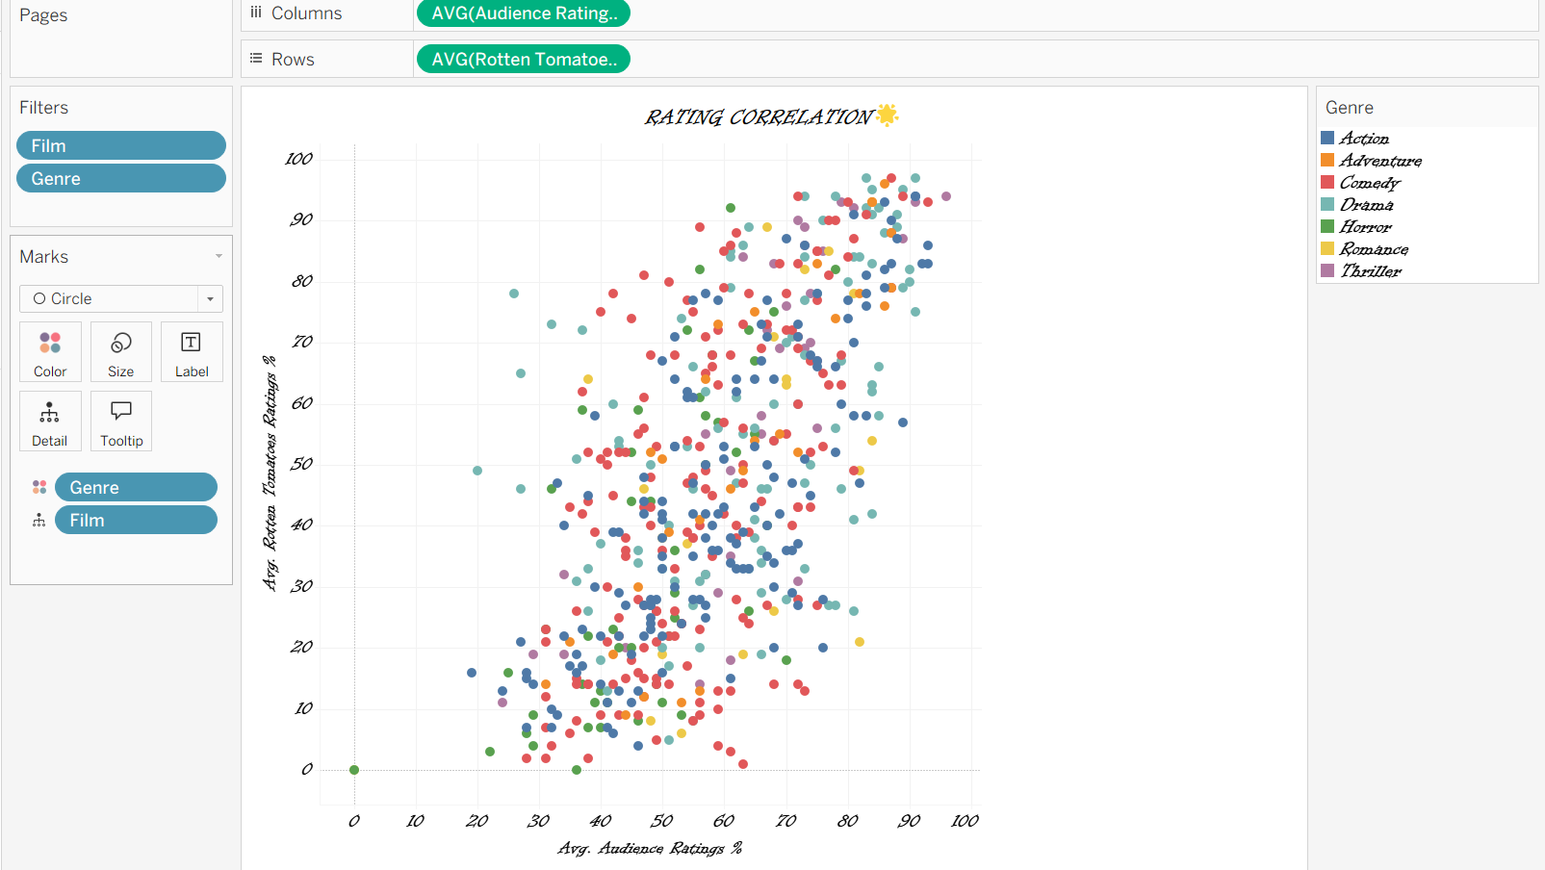
INTERPRETATION: Shows the relationship between audience ratings and critic ratings and helps identify whether their opinions are similar or different.

Task 3: Create a chart displaying the number of over released under every Genre over a period of time.
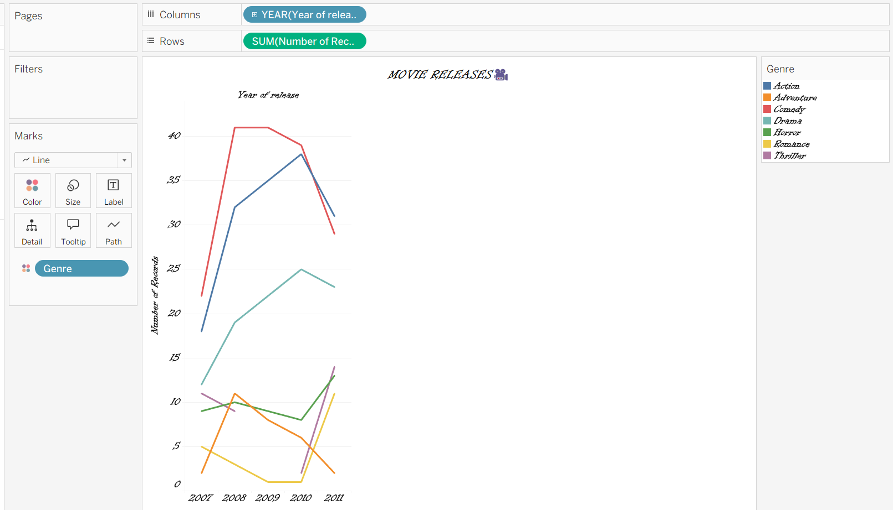
INTERPRETATION: Displays the number of movies released in each genre over time and helps identify popular and less common genres.

Task 4: Create a chart to visualize the comparison between the Ratings over a period of time.
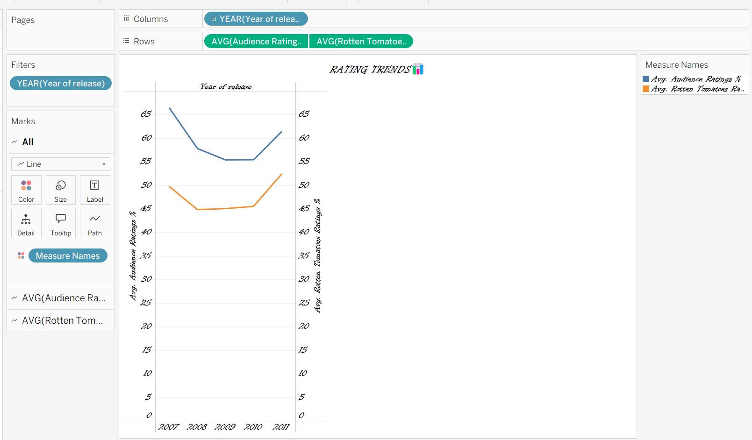
INTERPRETATION: Compares audience and critic ratings across different years to identify changes in movie ratings.

Task 5: Create a chart that will display the Budget of Top 3 Movies by both Audience and Critics rating. Also segregate the chart by Genre.
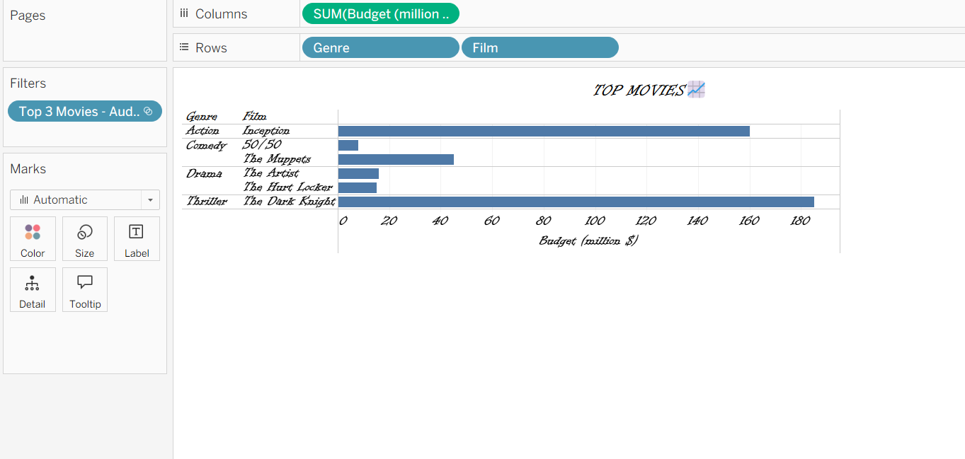
INTERPRETATION: Displays the budgets of the top three movies based on audience and critic ratings, separated by genre, to compare their budgets and ratings.

Task 6: Create a Dashboard, using the above charts.
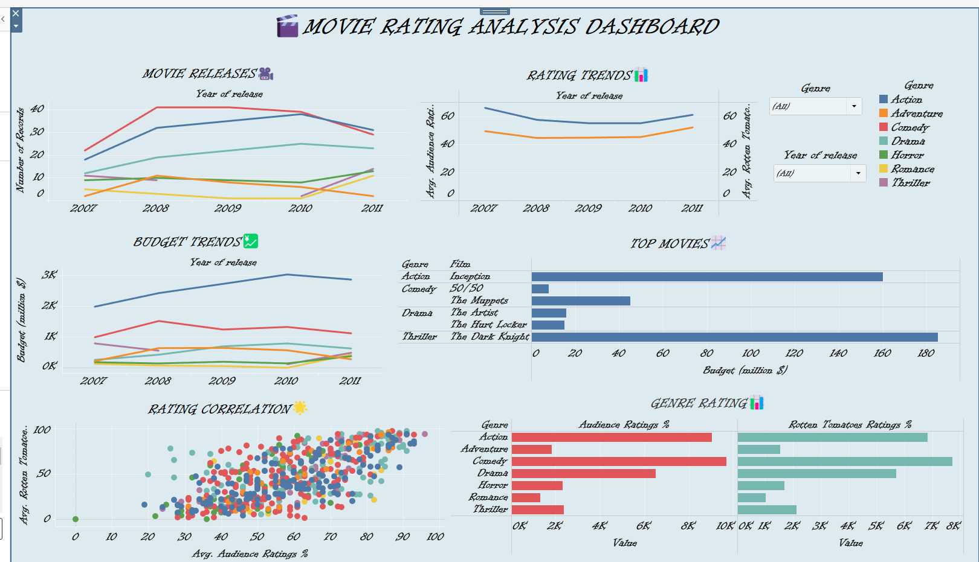
INTERPRETATION:
The analysis helps the movie review company understand budget distribution, movie release trends, and differences between audience and critic opinions. The dashboard provides a combined view of movie performance across genres and years, supporting better analysis and reporting.

